# Intradiem Basics

How the Intradiem Desktop Works

Your Responsibilities

What to Expect – Logging In

What to Expect – Main Menu Screen

What to Expect – Schedules

What to Expect – Messages & Activities

What to Expect – Prompts

What to Expect – Tasks & Assignments

Frequently Asked Questions

**Description:** Overview of what to expect when logging into and navigating the Intradiem Desktop.

|  |
| --- |
| How the Intradiem Desktop Works |

Through the following functions, the Intradiem Desktop allows you to take greater control of your schedule, improve performance through custom development opportunities, and track your messages and daily activities:

* Delivery of messages and notifications to your Desktop
* Constant monitoring of your status, schedule, and other factors
* Sends offers for PTO, FHOL, UTO and / or OT, and automatically adjusts your schedule
* Delivers off-phone activity opportunities, such as training, to your Desktop

Top of the Document

|  |
| --- |
| Your Responsibilities |

1. Always remain logged into the Intradiem Desktop.

* This allows you to receive alerts, messages and schedule offers.

1. Take calls as usual and await staffing offers, messages or sessions, which will likely arrive as prompts on your Desktop (above open applications).
2. When you receive a Yes / No question, answer the question either way.

* After you respond, take necessary actions based on the offer and processes.
* If you accept the offer, unless otherwise directed, wait for a confirmation message.

1. Prior to attending a scheduled event / activity (**Examples:** Lunch, break, or training):

* Complete the customer interaction first.
* Refer to your schedule to ensure adherence.
* Change phone state (as appropriate) and attend event / activity.
* When complete, return to your next scheduled activity.

1. Check your messages after you’ve been away from your computer.

Top of the Document

|  |
| --- |
| What to Expect – Logging In |

Each day Intradiem will automatically launch and log in upon startup. Manual log in is not required.

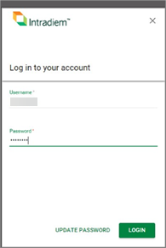

**Notes:**

* To minimize the Intradiem log in window, click the “x” in the upper right corner of the log in prompt. Icon - Important For optimal delivery you should minimize Intradiem each day after logging in.
* If Intradiem does not automatically launch, click the **Intradiem Desktop icon** on your desktop.

Top of the Document

|  |
| --- |
| What to Expect – Main Menu Screen |

The Intradiem Desktop Main Menu screen includes access to the following features:

* Tasks & Assignments
* Messages & Activities
* Schedules

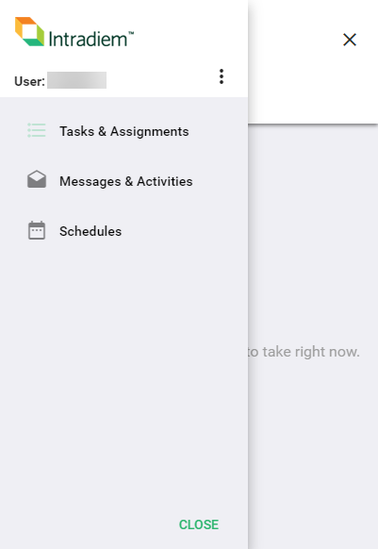

Top of the Document

|  |
| --- |
| What to Expect – Schedules |

The Schedules feature allows agents to track their schedule and day-to-day activities and can be accessed by clicking the **Schedules** option from the main menu.

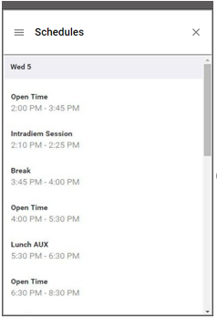

**Note:** This feature provides a quick view of a 2-hour window of your current day schedule. Because there is a slight lag time between this view and your actual schedule, continue to rely on the NICE Webstation for the most current data and your overall schedule views.

Top of the Document

|  |
| --- |
| What to Expect – Messages & Activities |

The Messages & Activities feature displays past messages, alerts, notifications and activities, and can be accessed via the Messages & Activities option from the main menu.

1. The **Messages** tab displays all your messages and notifications.

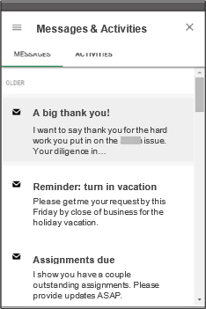

**Notes:**

* A closed envelope icon indicates an unread message while an open envelope icon indicates a message which has been read.
* Clicking on any message from your message list will allow you to view that message in full screen.

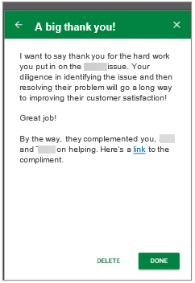

**Note:** In full screen view, the Delete button will remove a message from your list while the Done button will retain it.

1. The **Activities** tab displays a log of all your system events and messages, including start and completion dates / times, messages received, and login / logout data.

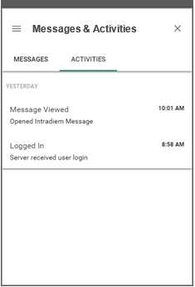

Top of the Document

|  |
| --- |
| What to Expect – Prompts |

A key feature of the Intradiem Desktop is the ability to message and prompt you directly on your computer. These prompt windows appear above active applications and can be tracked for delivery. Prompts come in a few different forms:

1. Message prompts deliver communication and can be generated manually by your Supervisor, team leader or automatically within a rule.

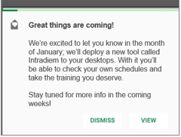

1. Alert prompts are usually triggered automatically as part of a rule. They help with handle time and adherence.

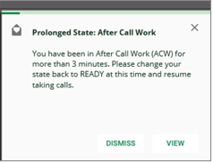

1. Question prompts give you the option to answer Yes or No. (**Examples:** Offers to leave early, work overtime, ask for assistance and more.)

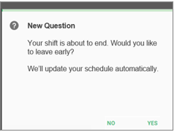

1. Session prompts prompt you to start training, complete a task / assignment, or begin an activity.

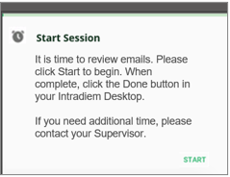

Top of the Document

|  |
| --- |
| What to Expect – Tasks & Assignments |

The Tasks & Assignments feature includes two sections that track your open and completed assignments and can be accessed by clicking the “Tasks & Assignments” option from the main menu.

1. The To Do tab displays a list of your open assignments, which can be accessed by clicking on them.

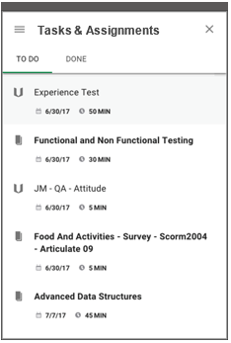

1. The Done tab displays complete assignments, which may be reopened for view. Training scores (within Intradiem) can be tracked from this screen.

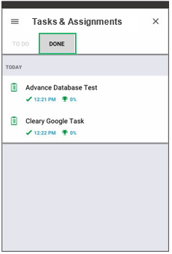

1. The Icon legend shown as Figure 1 provides examples of and demonstrates the meaning of various icons you may see within the Tasks & Assignments feature.

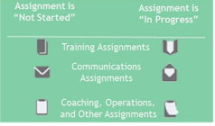

Figure 1

Top of the Document

|  |
| --- |
| Frequently Asked Questions |

Refer to as needed:

|  |  |
| --- | --- |
| **Question** | **Answer** |
| How do I log into Intradiem? | You are logged in automatically when you log into your workstation. The solution will run in a minimized state. If you are disconnected, click on the Intradiem Desktop icon on your desktop to restart the application as soon as possible. You must be logged in to receive Intradiem prompts. |
| Can I receive prompts if my application is minimized? | Yes, you will receive prompts providing you are logged into the Intradiem Desktop. Even if your application is running in a minimized state on your desktop, you will still receive messages, staffing offers and notifications when it is appropriate. |
| What if I miss an offer because I am on a call? | Depending on how your company uses the solution, you may potentially receive staffing offers while on a call. Finish your call and if you miss the offer – don’t worry! Continue to work your shift as scheduled and wait until you receive another offer. |
| Do I need to keep track of schedule adjustments? | No, you do not need to manually keep track of any schedule adjustments that occur from accepting staffing offers. The system automatically tracks those changes and sends them to your Workforce Management (WFM) system so your schedule can be updated appropriately. |

Top of the Document

Not To Be Reproduced Or Disclosed to Others Without Prior Written Approval

**ELECTRONIC DATA = OFFICIAL VERSION / PAPER COPY = INFORMATIONAL ONLY**